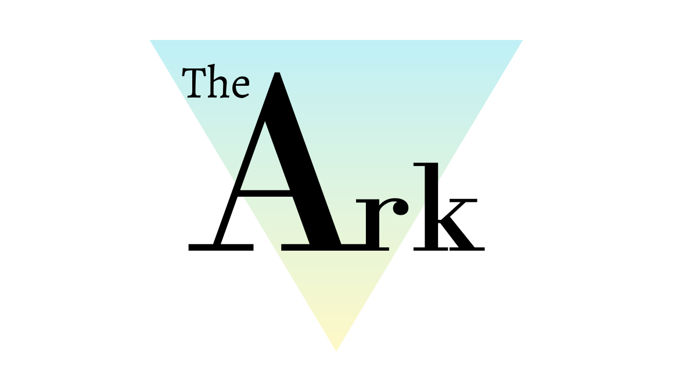

Whistle Blowing Policy

Policy Ref: ARK11v1

Produced by the Head of Centre, Head of Teaching and Learning.

This policy will not discriminate either directly or indirectly against any individual on grounds of sex, race, ethnicity or national origin, gender, sexual orientation, marital status, religion or belief, age, disability, socioeconomic status, offending background or any other personal characteristic.

Prepared by: | Katie Davies | Reviewed by: | Steven Speed
Job Title: | Head of Teaching and Learning | Job Title: | Head of Centre
Signed: | 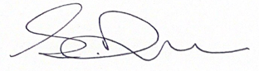 | Signed: | 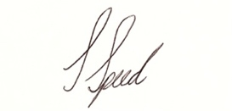
Date: | 09/02/21 | Date: | 09/02/21

Record of Changes:

Version | Issue Date | Changes | Initials
V1 |  | Initial issue | SS

Date of Next Review:
July 2022

- Definitions
Throughout this policy document The Ark Wigan Ltd is referred to as ‘The Ark’.

- Introduction
This Whistleblowing Policy encourages and enables individuals to make a “protected disclosure” to raise serious concerns to The Ark in the public interest in line with the Public Interest Disclosure Act 2013.

We are committed to the highest possible standards of openness, honesty, integrity and accountability therefore in line with that commitment we expect people who have serious concerns about any aspect of The Ark’s work to come forward and voice those concerns.

The purpose of this policy is to provide the approved way for concerns to be raised. An individual must reasonably believe that the disclosure tends to show past, present, or likely future wrongdoing falling into one or more of the following categories:

- criminal offences (this may include, for example, types of financial impropriety such as fraud)
- failure to comply with an obligation set out in law
- miscarriages of justice
- endangering of someone’s health and safety
- damage to the environment
- a serious safeguarding or child protection concern including any involvement in radicalisation or extremist activity
- Covering up wrongdoing in the above categories.

- Scope
Any serious concerns that an individual may have about any aspect of service provision or the conduct of members of The Ark’s community, or those acting on behalf of The Ark can be reported under the Whistleblowing Policy.

- Policy Statement
The Ark welcomes the communication of genuine concerns and is committed to dealing with them responsibly, promptly, openly, and professionally.

Any employee found to be subjecting an actual whistle-blower to any form of victimisation, discrimination or bullying and harassment will be dealt with under the The Ark’s Disciplinary procedures. Whistle-blowers will not suffer any form of detriment because of raising their concerns.
However, if it is evident that an employee who is acting as a whistle-blower has made a false allegation, The Ark’s Disciplinary procedure will be put in place.

This policy will not discriminate either directly or indirectly against any individual on grounds of sex, race, ethnicity or national origin, sexual orientation, marital status, religion or belief, age, disability, socioeconomic status, offending background or any other personal characteristic.

- Key Documents and Duties
The Ark may make a disclosure to an appropriate external body prescribed by law. This list of ‘prescribed’ organisations and bodies can be found in information on the GOV.UK website:

https://www.gov.uk/government/publications/blowing-the-whistle-list-of-prescribed-people-and-bodies--2/whistleblowing-list-of-prescribed-people-and-bodies

The NSPCC whistleblowing helpline is available for staff who do not feel they are able to raise concerns regarding child protection failures internally. The NSPCC whistleblowing helpline number is 0800 028 0285 ‐ available from 8:00 AM to 8:00 PM, Monday to Friday and via email, see:

https://www.nspcc.org.uk/keeping-children-safe/reporting-abuse/dedicated-helplines/

- Responsibilities
All individuals have a duty of confidentiality to The Ark.

- Procedures
To ensure that there is no confusion about the nature of the concern being raised, it is important to refer to this policy in all correspondence. If there is a more suitable policy to deal with the nature of the concern, the whistle-blower will be advised accordingly.
It is recognised that there may be matters that cannot be dealt with internally and whereby external authorities will need to become involved. Where this is necessary, The Ark reserves the right to make this referral themselves without the whistle-blower’s consent. The Police will be informed in all instances where a criminal offence may have occurred.

If told not to raise or pursue a concern, individuals should not agree to remain silent. They should report the matter to the most appropriate senior manager within The Ark. An instruction to cover up wrongdoing is itself a disciplinary offence.

To raise a Whistleblowing concern, a detailed letter should be sent to the Head of Centre at The Ark.
Once an individual has formally raised a concern, The Ark will commence an investigation and the whistle-blower will be contacted to acknowledge the concern and inform them of the action that The Ark intends to take.

While the purpose of the policy is to enable The Ark to investigate possible malpractice and take appropriate steps to deal with it, it may not be possible to give the person raising the concern details of the action that will be taken where this may infringe a duty of confidentiality that is owed to someone else.

An investigation will be conducted by a suitable representative of The Ark. If the concern has safeguarding implications, The Ark will discuss the details with a Senior Designated Safeguarding Officer:

- For Adults WIGAN COUNCIL Adult social care team 01942 828777
- For 18 years or under WIGAN COUNCIL Children’s duty team 01942 828300
If someone else has the same concern, it is advisable that they raise their concerns separately and do not discuss the issue to prevent any conflict of interest or opportunity to jeopardise an investigation.

All concerns raised under this policy will be treated as confidential and in a timely and sensitive manner. The identity of the individual raising the concern or making the disclosure will be kept confidential so long as this does not hinder any investigation. Concerns or disclosures expressed anonymously are less credible but will nevertheless be considered.

- Links with other Ark policies

- Safeguarding Policy - Child Protection Policy
- Safeguarding Policy - Adults at Risk

