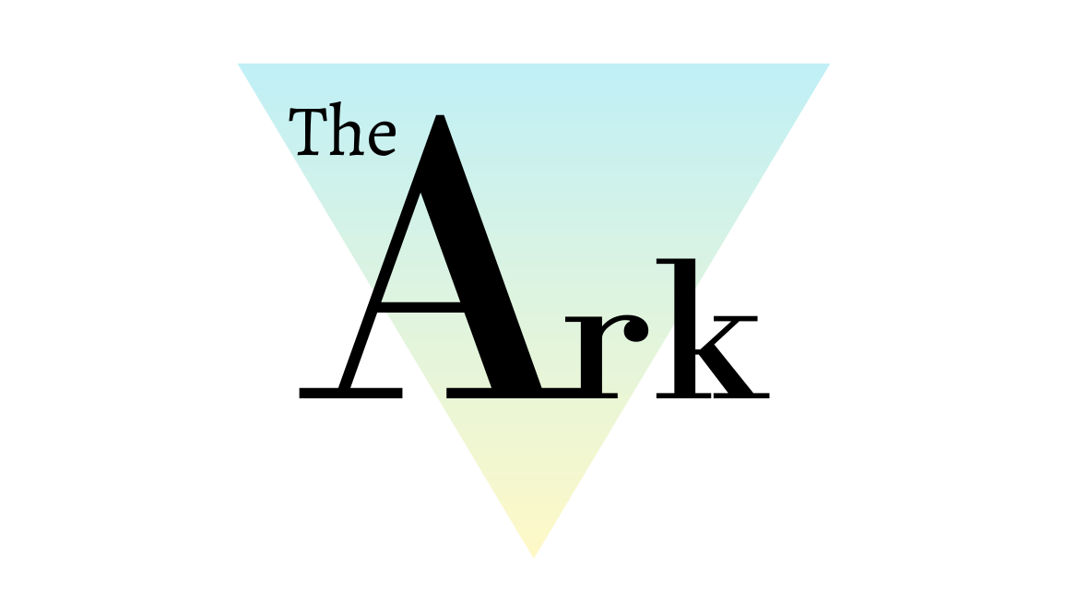

Equality and Diversity Policy

Policy Ref: ARK2v1

Produced by the Head of Teaching and Learning. Reviewed by Head of Centre.
This policy will not discriminate either directly or indirectly against any individual on grounds of sex, race, ethnicity or national origin, gender, sexual orientation, marital status, religion or belief, age, disability, socioeconomic status, offending background or any other personal characteristic.

Prepared by: | Katie Davies | Reviewed by: | Steven Speed
Job Title: | Head of Teaching and Learning | Job Title: | Head of Centre
Signed: | 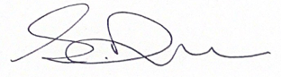 | Signed: | 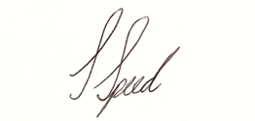
Date: | 09/02/21 | Date: | 09/02/21

Record of Changes:
Version | Issue Date | Changes | Initials
V1 | February 2021 | Initial issue | SS

Date of Next Review:
January 2022
- Definitions
Throughout this policy document The Ark Wigan Ltd is referred to as ‘The Ark’.

- Introduction
The Ark is committed to ensuring that equality and diversity is promoted and championed throughout every aspect of our operations and that we fully comply with the requirements of all current, relevant legislation
The Ark has developed a Mission, Vision and Values Statement which embeds Equality and Diversity.
Through this, we are dedicated to the education and development of the whole person and supporting all students to realise their full potential. We will encourage our students to build the necessary skills and qualifications to support them through a unique and challenging environment where every individual is valued, talents are recognised and nurtured, achievements are celebrated, and dedication is rewarded.
To achieve this, we will:
- Welcome all students to provide equal opportunities and encouragement.
- Deliver high standards of teaching and learning for all abilities.
- Provide both relevant and accessible, industry standard equipment.
- Uphold an environment built on mutual respect, positivity and inclusivity.
- Support and educate on the importance of mental health and well-being.
- Create, build and develop local, national and international partnerships.

Core values in daily life at The Ark are expressed as:
- Independence
- Resilience
- Empathy
- Inclusivity
- Integrity
- Collaboration
- Innovation

3. The Ark’s Aims and Objectives
1. To embed a learning culture which improves the standards of student achievement, raises aspirations and promotes independence across the full range of the Ark’s curriculum. We will focus on three key areas of outcomes for students:
1.1 Having excellent outcomes, attainment, progress across all courses and exceeding national benchmarks.
1.2 Raising students wellbeing, and in turn their goals.
1.3 Embed a holistic, student centred learning approach, consistently.,
2. To expand student participation, in partnership with other providers, through the offer of a wide range of high-quality courses that meet the needs of our students.
3. To work collaboratively with groups within The Ark’s local and extended community.
4. To develop the estate to provide an outstanding learning environment for the community.
5. To sustain a culture where all staff are committed to The Ark’s core values, where continuous professional development is encouraged, and organisational efficiency and effectiveness are achieved.
6. To maintain the The Ark’s financial stability.

- Policy Statement
This policy outlines the commitment of staff to promote equality across The Ark This involves tackling the barriers which could lead to unequal outcomes. We strive to promote equality of access and opportunity. We will celebrate and value diversity across The Ark.

We believe that equality at The Ark should permeate all aspects of life and is the responsibility of every member of the team at The Ark. Everyone should feel safe, secure, valued and of equal worth.

At The Ark equality is a key principle for treating all people fairly irrespective of their gender, ethnicity, disability, religious beliefs/faith tradition, sexual orientation, age or any other of the protected characteristics (Equality Act 2010).

- Duties and Key Documents
The Equality Act 2010:
The Equality and Diversity policy supports The Ark’s compliance with the principles and requirements of the Equality Act 2010
The Public Sector Equality Duty, (2011), covers 8 of the 9 ‘protected characteristics’. Being married or in a Civil Partnership is not a protected characteristic for FE institutions.

General Duty
The Duty (section 149 of the Equality Act 2010) – A public authority must in the exercise of its functions, have due regard to the need to:
- Eliminate discrimination, harassment, victimisation and any other conduct that is prohibited under the Act
- Advance¹ equality of opportunity between persons with or without a protected characteristic
- Foster good relations² between persons who have a relevant protected characteristic and persons who do not

The Ark is committed to meeting the aims of anti-discrimination legislation, by
- taking reasonable steps to remove any disadvantages experienced by those who share a relevant protected characteristic.
- taking steps to meet the needs of those who share a protected characteristic.
- encouraging those with a relevant protected characteristic to participate in activity where participation by such persons is disproportionately low.
- meeting the needs of disabled people and taking reasonable steps to take account of impairments.
Specific Duty
We will not discriminate against, harass or victimise any member of our team, or student, prospective student or their families, due to:
o Age o Disability o Gender reassignment
o Marriage or civil partnership o Pregnancy and maternity o Race o Religion or belief
o Sex o Sexual orientation

In addition, we respect the rights of carers.

The Ark aims to promote students’ spiritual, moral, social, and cultural development, with special emphasis on promoting equality, diversity and inclusion, whilst eradicating prejudicial incidents for students and staff.

The Ark is committed to not only eliminating discrimination, but also increasing understanding and appreciation of diversity.

¹ The term ‘advance’ replaces ‘promote’ – the intention is to move forward, to get somewhere and to achieve improved outcomes.
² ‘Foster good relations’ including having due regard to tackle prejudice and promote understanding.

- When does this policy apply?
This policy applies to all conduct within The Ark and also to conduct outside of the organisation (e.g. at meetings, social events and social interactions with colleagues/students) or which may impact on The Ark’s reputation (e.g. the expression of views on social media, contrary to the commitments expressed in this policy, that could be linked to The Ark).

- Goals
• To develop a fully inclusive, prejudice-free community, which recruits and retains students (14-18 and 19+) and staff from all sectors of society.
• To nurture the talents of all students and staff, irrespective of their background or characteristics, and develop them within a positive and supportive culture.
• To implement measures to ensure that there are no differences between different groups of students, irrespective of their background or characteristics
• To adopt and implement a skills strategy in support of students
• Encouraging compassion and open-mindedness
We are committed to having a balanced and fair curriculum. We believe that our students should be exposed to ideas and concepts that may challenge their understanding to help ensure that students learn to become more accepting and inclusive of others. Challenging and controversial concepts will be delivered in a way that prevents discrimination, and instead promotes inclusive attitudes. We will also respect the right of student and/or parents to withdraw their children from classes which pose conflicts to their own beliefs.

- Dealing with Prejudice
The Ark does not tolerate any form of prejudice-related incident. Whether direct or indirect, we treat discrimination against all stakeholders of The Ark with the utmost severity. When an incident is reported through a thorough reporting procedure The Ark is devoted to ensuring appropriate action is taken and a resolution is put into place which is both fair and firm.

All prejudice related incidents are recorded and reported to The Ark’s Governing Body on a termly basis.

At The Ark, our students are taught to be:
- Understanding of others
- Celebratory of cultural diversity
- Eager to reach their full potential
- Inclusive
- Aware of what constitutes discriminatory behaviour

The Ark employees will not:
- Discriminate against any member of the organisation
- Treat other members of the organisation unfairly

The Ark employee’s will:
- Promote diversity and equality
- Encourage and adopt an inclusive attitude o Lead by example o Follow company values and behaviours (Refer to the Staff Code of conduct Policy)

- Equality and Dignity in the workplace
Every member of staff is entitled to a working environment that promotes dignity, equality and respect for all. The Ark will not tolerate any acts of unlawful or unfair discrimination (including harassment) committed against an employee, contractor, job applicant or visitor because of a protected characteristic:

- Age
- Disability
- Gender reassignment
- Marital or civil partnership
- Pregnancy or maternity
- Race, colour, nationality, ethnic or national origin
- Religion or belief
- Gender
- Sexual orientation

Equality of opportunity and non-discrimination extends to the treatment of all members of The Ark. All staff members are obliged to act in accordance will the organisations various policies relating to equality.

We will guarantee that no redundancy is the result of direct or indirect prejudice. All disciplinary procedures are nonprejudicial, whether they result in warnings, dismissal, or any other disciplinary action.

Prejudice, in any form, is not tolerated at The Ark and we are continuously working towards a more accepting and respectful environment for our community.

Discrimination based on work pattern (part-time working, fixed term contract, flexible working) which is unjustifiable will also not be tolerated.

All employees will be encouraged to develop their skills and fulfil their potential and to take advantage of training, development and progression opportunities at The Ark. Selection for employment, promotion, training, or any other benefit will be based on aptitude and ability.

No form of intimidation, bullying or harassment will be tolerated. If you believe that you may have suffered discrimination because of any of the above protected characteristics, you should consider the appropriateness and feasibility of attempted informal resolution by discussion in the first instance with your line manager or another colleague in a relevant position of seniority. You may decide in the alternative to raise the matter through The Ark’s Harassment Policy or Grievance Policy. For types of discrimination see the Annex to this policy.

Allegations regarding potential breaches of this policy will be treated in confidence and investigated in accordance with the appropriate procedure. The Ark will ensure that individuals who make such allegations in good faith will not be victimised or treated less favourably as a result. However, false allegations of a breach of this policy which are found to have been made in bad faith will be dealt with under The Ark Disciplinary Policy.
A person found to have breached this policy may be subject to disciplinary action under The Ark Disciplinary Policy. Staff may also be personally liable for any acts of discrimination prohibited by this policy that they commit, meaning that they can be sued by the victim.

- Priorities

Moving forward, we seek to apply the following:
- Recruitment
Selection for employment at The Ark will be based on aptitude and ability. Further detail is set out in The Ark’s Safer Recruitment Policy. Where possible, The Ark will capture applicants’ diversity demographics as part of its recruitment processes to promote the elimination of unlawful discrimination, offering reasonable adjustments wherever necessary.

- Training
You may also be required to participate in training and development activities from time to time, to encourage the promotion of the principles of this policy.

- Promotion
All promotion decisions will be made based on merit and will not be influenced by any of the protected characteristics listed above. Promotion opportunities will be monitored to ensure equality of opportunity at all levels. Where appropriate, steps will be taken to identify and remove unnecessary or unjustifiable barriers to promotion.

- During employment
The terms and conditions of employment and facilities available to The Ark employees will be reviewed on a regular basis to ensure that access is not restricted by unlawful means and to provide appropriate conditions to meet the additional needs of disadvantaged or under-represented groups. The Ark will promote opportunities for staff to discuss any reasonable adjustment that are required to ensure that staff can fulfil their potential.

- Monitoring and Review
This policy will be reviewed on an ongoing basis by The Ark to assess its effectiveness and may be amended from time to time.

- Related Policies:
Grievance Policy
Harassment Policy
Safeguarding and Child Protection Policy
Safer Recruitment Policy
Staff Code of Conduct
Staff Disability Policy and Procedures
Staff Disciplinary Procedures
Staff Wellbeing Policy
Student Disability Policy
Teaching, Learning and Assessment Policy

Signed: 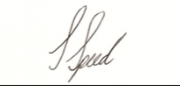 Head of Centre: Steven Speed

Appendix 1 – Types of Discrimination
There are various types of discrimination prohibited by this policy.

The main types are:

Direct Discrimination - occurs where one person is treated less favourably than another because of a protected characteristic set out in this policy. By way of example, refusing to promote a pregnant employee on the basis that she is shortly due to go on maternity leave would be direct discrimination on the protected characteristic of the employee's sex.
Indirect Discrimination - unjustifiable requirement or condition is applied, which appears to be the same for all, but which has a disproportionate, adverse effect on one group of people. This is discrimination even though there was no intention to discriminate.
Victimisation - where an employee is treated less favourably than others because they have asserted legal rights against The Ark or assisted a colleague in doing so.
Harassment - Harassment is “unwanted conduct related to a relevant protected characteristic, which has the purpose or effect of violating an individual’s dignity or creating an intimidating, hostile, degrading, humiliating or offensive environment for that individual.” It is important to remember that it is not the intention of the harasser but how the recipient perceives their behaviour, which determines whether harassment has occurred.

Appendix 2 – Equality and Diversity Declaration
By accepting this policy, staff are declaring that they have read and understood The Ark’s Equality and Diversity Policy and agree to work to the expected standards. Regardless of their background and circumstances, they agree to treat all colleagues and visitors with respect and dignity while carrying out the duties and responsibilities of their role at The Ark.

