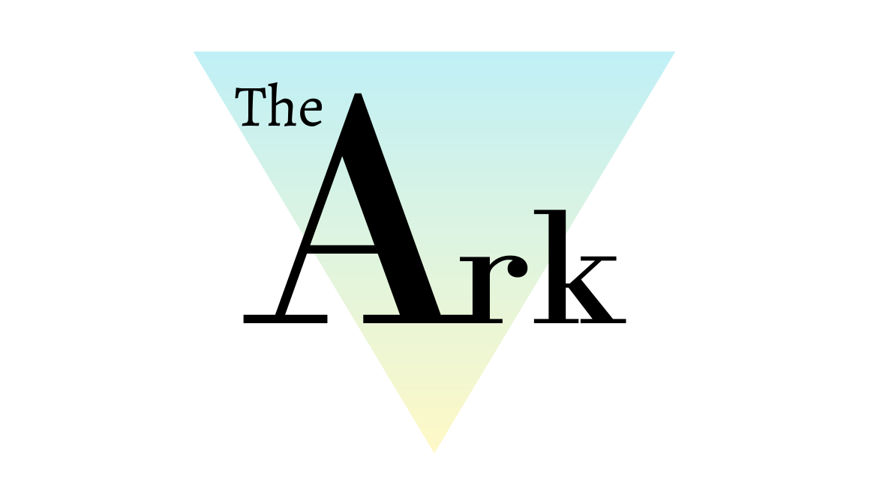

Safeguarding and Child Protection Policy

Policy Ref: ARK3v1

Produced by the Head of Centre, Head of Teaching and Learning

Prepared by: | Katie Davies | Reviewed by: | Steven Speed
Job Title: | Head of Teaching and Learning | Job Title: | Head of Centre
Signed: | 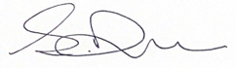 | Signed: | 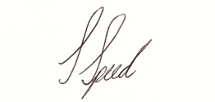
Date: | 05/07/21 | Date: | 05/07/21

Record of Changes:
Version | Issue Date | Changes | Initials
V1 |  | Initial issue | SS

Date of Next Review:
July 2022

Key Safeguarding Personnel
Role: | Name: | Tel: | Email:
Head of Centre  Designated Safeguarding Lead (DSL) | Steven Speed | 07828182820 | Steven.speed@thearkwigan.com
Head of Teaching and Learning  Designated Safeguarding Lead (DSL) | Katie Davies | 07488397639 | Katie.davies@thearkwigan.com

The key safeguarding responsibilities within each of the roles above are set out in Keeping Children Safe in Education 2021.

Useful Telephone contact Numbers
Children’s Social Care:  Child Protection Unit: | 01942 828300
Local Authority Designated Officer (LADO): | 01942 486042
Safeguarding in Education Team: | 01942 486025
Wigan Safeguarding Children Board | 01942 486111
Emergency Duty Team – Out of Hours: | 01942 8342436
Police – Safeguarding Vulnerable Persons Unit: | 0161 8566411

If you believe the child to be at immediate risk of significant harm or injury, you must call the Police on 999.

Mission Statement
The Ark Wigan is an education centre that is here to inspire our students by empowering their independence, aiding their growth and developing them academically, technically and emotionally, through a holistic approach.
To achieve this community, we will:
• Welcome all students to provide equal opportunities and encouragement.
• Deliver high standards of teaching and learning for all abilities.
• Teach industry recognised qualifications, to a high standard, with input from
local business leaders and suppliers, so that we can contribute to local and
regional economic development.
• Provide both relevant and accessible, industry standard equipment.
• Uphold an environment built on mutual respect, positivity and inclusivity.
• Support and educate on the importance of mental health and well-being.
• Deliver a tailored program to develop students physical, social, health,
citizenship and economic education.
Core values in daily life at The Ark Wigan are expressed as:
• Independence
• Resilience
• Empathy
• Inclusivity
• Integrity
• Collaboration
• Innovation

Local Context
Socio Economics
According to the most recent statistics from the Governments’ Public Health Department for socio economic deprivation, Wigan’s overall score was 3.1% higher than the national average which was 21.8%. This indicates that students in the Wigan Borough are more vulnerable to socio economic neglect than other young people on a national scale.
Domestic Violence
Domestic Violence is considered a significant issue in Wigan with a spike recorded between 2018 to 2019. The number of domestic abuse related crimes recorded by the Police during this period was 33.1% in comparison to 25.1% for the whole of England and the North West region. There are currently no up to date records for 2020 to 2021. These statistics suggest that a large number of our young people have either witnessed or been a victim of Domestic Violence in one of its many forms.

Mental Health
Although mental health is a national priority, it is of particular concern in Wigan with there being higher suicide rates than in both the North West Region and nationally. It was stated that one in five people getting mental health support in Wigan, are children. Additionally, due to the pandemic, mental health referrals rose by nearly one-third.

U18s Pregnancy
Pregnancy rates for under 18s in Wigan are higher than the North West and nationally with 22.2 per 1000 under 18s becoming pregnant, compared to 17.4 per 1000 in the North West region/ England respectively.

Demographics
Wigan is a geographical area made up of a significantly white population with the last data being recorded in 2011 as Wigan being 97.3% white in contrast with the national demographic which is 85.4% of the population. Wigan’s demographic given the political climate does make the young people of the area more susceptible to being influenced by extreme right-wing views.

According to the Home Office statistics the North West Region, in the year ending 31 March 2020, there were 6,287 referrals to prevent, Right Wing extremism. This is an increase of 10% compared to the previous year.
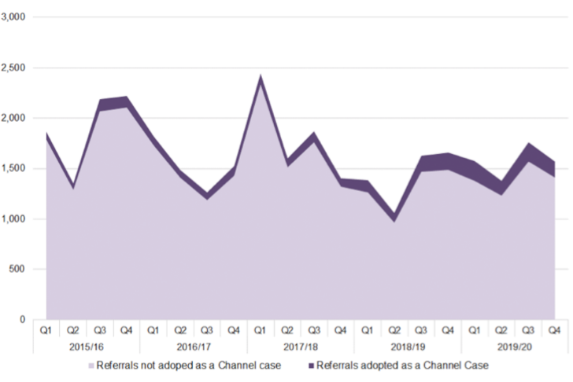

Drugs and Gangs
The rise of County Lines has also increased concerns of young people being pulled into, and exploited by, drug gangs. County Lines involve city-based drug gangs expanding their drug dealing into smaller towns and rural areas, (such as Wigan) with violence often being involved to protect the routes.

The National Crime Agency estimates that the number of dedicated phone lines dedicated to taking orders from users increased from about 720 to 2,000 between 2017 and 2018. Individuals, often vulnerable people susceptible to exploitation, will then take the drugs from the base to consumers. Two-thirds of police forces link County Lines to child exploitation by gangs.

Given the illicit nature of the operations, total involvement is difficult to capture but most referrals received by the National Crime Agency concern 15 to 17-year-olds, which means the age group of our student population are most at risk of this form of criminal activity.

Knife Crime
Since 2012, GMP has seen a growing trend in knife possession, usage and ‘threat & use’. Knife crime offences have almost doubled between 2015 and 2018. However, the proportion of violent offences has fallen (from 40% to 30%), with a corresponding increase in the proportion of possession offences (from 33% to 41%). The main age group associated with knife crime is 15 to 19 years of age.
Cyber Crime
There has been a national increase in cyber-crime and the age group of our student cohort is considered to be high risk for the following crimes;

o Average age of hackers –16
o Average age of cyber-criminal –17
o Strong link to Neuro-diversity 'disabilities?'(ASD,Aspergers) -more trusting/vulnerable
Online Radicalisation
Previously Google was a search engine that was used to radicalise individuals, but now other search engines are being used such as; Gab, 4Chan, Discord, Telegram.

Money Mules
Students’ bank accounts to transfer money acquired illegally through a courier service, or electronically, on behalf of others. Typically, the young person (mule) is paid for services with a small part of the money transferred.
Conclusion
The Ark sets out through its Safeguarding and Child Protection Policy to address the safeguarding trends outlined in this document through raising awareness with both staff and students. This is done through staff training, the targeted student sessions, the termly tutorials with their teachers and PSHE programme*. In doing so The Ark creates a safe place for young people to share any concerns they have and, through working with the appropriate external agencies, we seek to ensure all our young people are kept safe.

*PSHE programme is only applicable to any students we have that are under the age of 18 and on a government funded course.

Child Protection and Safeguarding Policy Statement
The Ark Wigan recognises fully the importance of its responsibility to the wellbeing of all children and young people and to the guidance, it will provide for its staff. It continues to be our highest priority. We are committed to the contribution we can provide in protecting and safeguarding young people.

- Definitions
Throughout this policy document The Ark Wigan Ltd is referred to as ‘The Ark’.
Child: The Children Acts 1989 and 2004, states a child is anyone who has not reached their 18th birthday. The commitment to safeguarding and promoting the welfare of children however will extend to all children who visit The Ark as well as all students enrolled on courses.

Safeguarding and promoting the welfare of children is everyone’s responsibility. Everyone who comes into contact with children and their families and carers has a role to play in safeguarding children. In order to fulfil this responsibility effectively, all professionals should make sure their approach is child-centred. This means that they should consider, at all times, what is in the best interest of the child.

Child protection: ‘Part of safeguarding and promoting welfare. This refers to the activity that is undertaken to protect specific children who are suffering, or are likely to suffer, significant harm.’ (KCSiE 2021). Child Protection is one part of safeguarding and promoting the welfare of children and refers to the activity that is undertaken to protect children who are suffering, or at risk of suffering significant harm.
The definitions of physical abuse, emotional abuse, sexual abuse and neglect are set out in the DFE guidance, Keeping Children Safe in Education 2021.

- The Ark’s Aims and Objectives
The aim of this policy is to safeguard and promote the welfare of any potential young person in our care and we do this by ensuring:
• All our potential students are safe and protected from harm and/or maltreatment
• A young person’s mental and physical health or development is not impaired in any way
• Safeguarding procedures are in place to help potential students to feel safe and learn to stay safe
• All staff are aware of the expected behaviours and the legal responsibilities in relation to safeguarding and child protection.
• All agencies are providing appropriate and effective support to children and young people that this is ensured through adoption of the Early Help framework.

- Policy
This policy has been developed in accordance with the principles established by
• The Children Act 1989 (as amended).
• The Children and Social Work Act 2017.
• The Safeguarding Vulnerable Groups Act 2006.
• Working Together to Safeguard Children 2018.
• Keeping Children Safe in Education 2020

- Key Documents and Duties
Other key documents are noted, which have prompted changes to safeguarding requirements over time. This policy references these throughout where relevant:
• Keeping Children safe in Education
• Sexual Violence and Sexual Harassment Between Children in Schools and Colleges (guidance document) 2018.
• Childcare (Early Years Provision Free of Charge) (Extended Entitlement) (Amendment) Regulations 2018.
• Childcare Act 2006 (as amended in 2018).

- Goals

We recognise that all adults, including any temporary staff we may have, volunteers and governors have a full and active part to play in protecting our students from harm, and that the young person’s welfare is our paramount concern.

All staff believe that our education setting should provide a caring, positive, safe and stimulating environment that promotes the social, physical and moral development of the young person. We recognise that a young person who is neglected, abused or witness violence may feel helpless and humiliated, may blame themselves, and find it difficult to develop and maintain a sense of worth.

We recognise that The Ark may provide the only stability in the lives of young people who have been abused or are at risk of harm. We accept that research shows that the behaviour of a young person in these circumstances may range from that which is perceived to be normal to aggressive or withdrawn. We recognise that the Early Help framework provides opportunities to intervene early and prevent safeguarding issues developing, as well as providing a framework for appropriate support to be wrapped around the young person and their family.

- Staff and Student safety
The Ark will ensure student and staff safety by;
• There is a Safeguarding, Child Protection policy together with a Staff Code of Conduct policy.
• The Ark operates safer recruitment procedures by ensuring that there is at least one person on every recruitment panel that has completed Safer Recruitment training.
• The education setting has procedures for dealing with allegations of abuse against staff and volunteers and to make a referral to the DBS if a person in regulated activity has been dismissed or removed due to safeguarding concerns, or would have, had they not resigned.
• A senior leader has Designated Safeguarding Lead (DSL) responsibility.
• On appointment, the DSL undertakes interagency training and also undertakes DSL “new to role” training and an “update” course every 2 years.
• All other staff have access to safeguarding training as appropriate.
• Any weaknesses in Child Protection processes and procedures are remedied immediately.
• A member of the board of governers, usually the Chair, is nominated to liaise with the LA on safeguarding issues and in the event of an allegation of abuse made against the Head of Centre.
• Safeguarding and Child Protection policies and procedures are reviewed annually.
• That enhanced DBS checks are in place for all staff.

The two lead DSL have undertaken the relevant training, and, upon appointment will undertake DSL new to role training followed by biannual updates.
The DSL involved in recruitment and at least one member of the governing board will also complete safer recruitment training, to be renewed every 2 years.
The name of the designated members of staff for Child Protection (DSLs) will be clearly visible in the Learning Centre, with a statement explaining the referral process.
All members of staff are trained in, and receive, regular updates in e-safety and reporting concerns.
All new members of staff will have access to our Safeguarding and Child Protection Policy on our secure server, with the DSL’s names clearly displayed, as part of their induction.
All other staff, volunteers and governors, have child protection awareness training, updated by the DSL as appropriate, to maintain their understanding of the signs and indicators of abuse.
Child protection and safeguarding concerns or allegations against adults working in the Ark are referred to LADO for advice and any member of staff found not suitable to work with children or young people including when a transferable risk is identified will be notified to the Disclosure and Barring Service (DBS) for consideration for barring, following resignation, dismissal, or when The Ark ceases to use their service as a result of a substantiated allegation, in the case of a volunteer.
All parents/carers are made aware of the staff members responsible for safeguarding and how to contact them, as well as a link to the Safeguarding and Child Protection Policy via the website.
The Policy is available publicly either on the website or by other means. Parents/ Carers are made aware of this policy and their entitlement to have a copy of it via the website.
All visitors complete a sign in / out form, wear a visitor’s lanyard and are provided with safeguarding information including the contact details of safeguarding personnel.
Visitors of a professional role are asked to provide evidence of their role and employment details (usually an identity badge) upon arrival at the Centre.
Any unauthorised visitors will be refused entry into the Learning Centre and/or the secured student areas areas.
Our procedures will be reviewed and updated regularly.
Safe Centre, Safe Staff

Our E-Safety Policy reflects the consideration The Ark gives to the protection of our young people, both physically within the education setting environment and, for example, in relation to internet use and when away from Learning Centre, undertaking off site trips and visits.

Lockdown Procedures
The purpose of this procedure is to provide emergency preparedness and general direction to The Ark community on how to respond during an incident in which a lockdown might reduce damage, injury or death and during which the site cannot be safely evacuated. It is based on the National Counter Terrorism Security Office (NaCTSO) Guidance Note 1/2015 – Developing Dynamic Lockdown Procedures.
Each member of staff will, to the best of their ability, have to manage the situation they find themselves in as best they can but there is no expectation that anyone should act in a manner which is detrimental to their well-being.

- Responsibilities

The Designated Safeguarding Lead
The role of the DSL will be to;
- Help promote educational outcomes by sharing the information about the welfare, safeguarding and child protection issues that students, including young people with a social worker, are experiencing, or have experienced, with relevant teachers, support staff and Senior Leadership Team.
- Ensure that staff who work with vulnerable young people are aware of their safeguarding context.
- Keeping written/electronic records of concerns about a child even if there is no need to make an immediate referral.
- Ensuring that all such records are kept confidentially and securely and are separate from student’s record, until the student’s 25th birthday, and are shared if there is a move to another educational setting.
- Making sure when a student leaves, the safeguarding file is transferred to the new education setting as soon as possible. This should be transferred separately from the main student file, ensuring secure transit, and confirmation of receipt should be obtained. Receiving schools and colleges should ensure key staff such as designated safeguarding leads and the named person with oversight for SEN in colleges, are aware as required.
- Ensuring that any student currently with a Child Protection plan who is absent from the Centre without explanation for two days is referred to their key worker’s Social Care Team.
- Organising child protection induction and update training every 2 years for all staff.
- Providing an annual report for the governing board detailing any changes to the policy and procedures; training undertaken by the Designated Safeguarding Lead, and by all staff and governors; number and type of incidents/cases, and a number of children on the child protection register (anonymised).
- Liaising with other agencies and professionals.

- Supporting Young People
Early Help Assessments
The Centre will consider the need for an Early Help assessment when it is identified that there are low level concerns or emerging needs. It is the responsibility of the Centre to initiate Early Help to identify what the family’s strengths and needs are. This will inform whether the Centre can support the family or whether a referral to another agency is needed.
If at any point during the Early Help process, the risk increases and the Centre becomes concerned that the young person is, or is likely to suffer significant harm, then a referral will be made to children’s social care.

Support from the Centre
Our Centre will support young people by:
• Encouraging self-esteem and self-assertiveness through the PSHE programme, curriculum, as well as our relationships, whilst not condoning aggression or bullying.
• Promoting healthy relationships
• Promoting a caring, safe and positive environment within the centre.
• Liaising and working together with all other support services and those agencies involved in the safeguarding of young people.
• Notifying Social Care as soon as there is a significant concern.
- Providing continuing support to a young person, about whom there have been concerns, who leaves the Centre, by ensuring that appropriate information is shared with their new educational setting.

Young People with Special Education Needs and Disabilities
The Centre recognises that additional barriers can exist when recognising abuse and neglect in this group of children. These can include:
• assumptions that indicators of possible abuse such as behaviour, mood and injury relate to the child’s disability without further exploration;
• being more prone to peer group isolation than other young people;
• the potential for young people with SEN and disabilities being disproportionally impacted by behaviours such as bullying, sexual violence and sexual harassment without outwardly showing any signs; and
• communication barriers and difficulties in overcoming these barriers

- Information Sharing
Government Guidance
The Children Act 20043 requires each person or organisation to which the duties apply to have regard to any guidance given to them by the Secretary of State; specifically:

• Section 10: Co-operation to improve well-being
• Section 11: Arrangements to safeguard and promote welfare
• Section 16k: Guidance by Secretary of State relating to sections 16E-16J

Section 175 (3) of the Education Act 20024 places a duty on the governing board of an institution within the further education sector to ‘make arrangements for ensuring that their functions relating to the conduct of the institution are exercised with a view to safeguarding and promoting the welfare of children receiving education or training at the institution.’

Colleges/Training Centre’s must have regard for DfE statutory guidance. This child protection policy should be read alongside Working Together to Safeguard Children (2018)5 and ‘Keeping Children Safe in Education (2020) and all staff must read and understand Part 1 and Annex A of KCSiE (2020).

Working Together to Safeguard Children (DfE 2018) makes it clear that protecting children from harm and promoting their welfare depends upon a shared responsibility and effective joint working between different agencies:

‘Everyone who works with children has a responsibility for keeping them safe. No single practitioner can have a full picture of a child’s needs and circumstances and, if children and families are to receive the right help at the right time, everyone who comes into contact with them has a role to play in identifying concerns, sharing information and taking prompt action.’

In addition, Working Together to Safeguard Children also reinforces the need to take action to provide early help before statutory services are required:

‘Providing early help is more effective in promoting the welfare of children than reacting later. Early Help means providing support as soon as a problem emerges, at any point in a child’s life, from the foundation years through to the teenage years.’

The Teaching Standards (DfE 2013) also requires all tutors to ‘uphold public trust in the profession and maintain high standards of ethics and behaviour, within and outside The Ark, including:

• treating students with dignity, building relationships rooted in mutual respect, and at all times observing proper boundaries appropriate to a tutor’s professional position
• having regard for the need to safeguard students
’ wellbeing, in accordance with statutory provisions
• showing tolerance of and respect for the rights of others.

The Ark therefore understands its responsibility to engage with other professionals in Early Help Assessments when a child’s needs according to the Local Safeguarding Children Partnership’s Responding to Need and Level of Needs framework sit below the requirement for a statutory assessment.

- Key Organisations

Key organisations who have a duty under section 11 of the Children Act 2004 to have arrangements in place to safeguard and promote the welfare of young people are:
• The local authority;
• NHS England;
• Clinical commissioning groups;
• NHS Trusts, NHS Foundation Trusts;
• The local policing body;
• British Transport Police Authority;
• Prisons;
• National Probation Service and Community Rehabilitation Companies
• Youth offending teams and
• Bodies within the education and /or voluntary sectors, and any individual to the extent that they are providing services in pursuance of section 74 of the Education and Skills Act 2008.

We will always undertake to share our intention to refer a young person to Social Care with their parents/carers unless to do so could put the young person at greater risk of harm or impede a criminal investigation.

- Supporting Staff

Staff Wellbeing
The Centre will work with partners in the safeguarding partnership to ensure positive outcomes for young people.
We recognise that staff working in the Centre who have become involved with a young person who has suffered harm, or appears to be likely to suffer harm, may find the situation stressful and upsetting.
We will support such staff by providing an opportunity to talk through their anxieties with the DSL and to seek further support as appropriate. Centre also has a Head of Student Wellbeing that is considering ways on how to best support staff who are working alongside young people who have complex safeguarding needs.
The DSL has monthly supervision sessions with an external consultant to discuss serious Safeguarding cases as they occur.

Managing allegations against staff and volunteers

When an allegation is made against a member of staff, set procedures must be followed. It is rare for a child to make an entirely false or malicious allegation, although misunderstandings and misinterpretations of events can and do happen. A child may also make an allegation against an innocent party because they are too afraid to name the real perpetrator. Even so, we must accept that some adults do pose a serious risk to children’s welfare and safety and we must act on every allegation made. Staff who are the subject of an allegation have the right to have their case dealt with fairly, quickly and consistently and to be kept informed of its progress. Suspension is not mandatory, nor is it automatic but, in some cases, staff may be suspended where this is deemed to be the best way to ensure that children are protected.

All staff and volunteers must report any concerns about a member of staff’s behaviour towards children to the Director. Concerns can also be discussed with the Designated Safeguarding Lead.

Concerns can also be taken directly to the Local Authority Designated Officer (L.A.D.O.), if needed, via Children’s Services. Section 4 of the DfE guidance Keeping Children Safe in Education 2020 provides further guidance.

In addition, the Sexual Offences Act 2003 makes it clear that all members of staff are in a position of trust and would therefore be committing a criminal offence to have a sexual relationship with a young person below the age of 18, even if that student is over the age of consent. In addition, it would be a breach of trust to have a relationship with any student over the age of 18. This would result in the issue being addressed under the formal disciplinary procedure and may constitute gross misconduct.

- Prevention

The Counter-Terrorism and Security Act 2015 places a duty upon local authorities and educational providers to ‘have due regard to the need to prevent people from being drawn into terrorism’ (CTSA 2015). ‘The fundamental aims of Prevent, as part of the revised 2018 Contest Strategy are, “to safeguard vulnerable people to stop them becoming terrorists or supporting terrorism.” (Work Based Learners and the Prevent Statutory Duty 2018).

The DfE has provided statutory guidance for colleges and childcare providers: ‘Revised Prevent Duty Guidance: England and Wales’ (DfE 2015). The guidance summarises the requirements in terms of four general themes:

• risk assessment
• working in partnership
• staff training
• IT policies.

The Ark will ensure that staff are aware of the indicators of extremism and radicalisation and know how to respond in keeping with local and national guidance. Staff will use their judgment in identifying children who might be at risk of radicalisation and act proportionately, which may include making a referral to the Channel programme. Equally, children will be made aware of the risks and support available to them. We will ensure that children are safe from terrorist and extremist material when accessing the internet at The Ark. The Government has developed an ‘educate against hate’ website providing information and resources for colleges and parents to support them to recognise and address extremism and radicalisation in young people.

Child Sexual Exploitation (CSE) and Child Criminal Exploitation (CCE)

Both CSE and CCE involves exploitative situations, contexts and relationships where young people receive something (for example food, accommodation, drugs, alcohol, gifts, money or in some cases simply affection) as a result of engaging in sexual activities. Sexual exploitation can take many forms ranging from the seemingly ‘consensual’ relationship where sex is exchanged for affection or gifts, to serious organised crime by gangs and groups. What marks out exploitation is an imbalance of power in the relationship. The perpetrator always holds some kind of power over the victim which increases as the exploitative relationship develops. Sexual exploitation involves varying degrees of coercion, intimidation or enticement, including unwanted pressure from peers to have sex, sexual bullying including cyberbullying and grooming. However, it’s also important to recognise that some young people who are being sexually exploited do not exhibit any external signs of this abuse.

One specific type of criminal exploitation is also known as 'county lines' and is when gangs and organised crime networks groom and exploit children to sell drugs. Often these children are made to travel across counties, and they use dedicated mobile phone 'lines' to supply drugs.

Female Genital Mutilation (FGM)

‘Section 5B of the Female Genital Mutilation Act 200311 (as inserted by section 74 of the Serious Crime Act 2015) places a statutory duty upon tutors along with regulated health and social care professionals in England and Wales, to report to the police where they discover (either through disclosure by the victim or visual evidence) that FGM appears to have been carried out on a girl under 18. Those failing to report such cases will face disciplinary sanctions. It will be rare for tutors to see visual evidence, and they should not be examining students, but the same definition of what is meant by “to discover that an act of FGM appears to have been carried out” is used for all professionals to whom this mandatory reporting duty applies. Information on when and how to make a report can be found at:

https://www.gov.uk/government/publications/mandatory-reporting-of-female-genital-mutilationprocedural-information

Tutors must personally report to the police cases where they discover that an act of FGM appears to have been carried out. Unless the tutor has a good reason not to, they should also still consider and discuss any such case with The Ark’s Designated Safeguarding Lead and involve children’s social care as appropriate. The duty does not apply in relation to at risk or suspected cases (i.e. where the tutor does not discover that an act of FGM appears to have been carried out, either through disclosure by the victim or visual evidence) or in cases where the woman is 18 or over. In these cases, tutors should follow local safeguarding procedures.

Additional information and resources relating to FGM can be found in the Female Genital Mutilation: Resource Pack, published by the Home office in 2020.

Peer on peer abuse

Within KCSIE 2021, ‘Peer on peer abuse (child to child)’ has been identified as a main area of concern within schools/colleges. All staff are to be aware that children can abuse other children and that it can happen both inside and outside of school or college and online.

It is essential that all staff are challenging inappropriate behaviours between peers that are abuse in nature. The emphasis is to not normalise abusive behaviour between peers.

It states in the KCSIE 2021 a list of what peer on peer abuse may consist of the following; bullying, abuse in intimate personal relationships between peers, physical abuse, sexual violence, sexual harassment, causing someone to engage in sexual activity without consent such as forcing someone to strip, consensual and non-consensual sharing of nudes/semi-nudes, up skirting and initiation/hazing type rituals.

All staff should be challenging any behaviour that they deem to be classed as peer on peer abuse and take the necessary steps of referral.

Mental Health

Within the KCSIE 2021, there is a big emphasis on all staff being aware that mental health problems can, in some cases, be an indicator that a child has suffered or is at risk of suffering abuse, neglect or exploitation.

It is advised that only appropriately trained professionals should attempt to diagnose a student with a mental health problem. It is for all staff to just be aware and if there is a concern of a mental health issue that it is a safeguarding concern and immediate action should be taken.

- Communicating with parents and visitors

The Ark is committed to the principles of Working Together to Safeguard Children which states that a ‘child centred approach is fundamental to safeguarding and promoting the welfare of every child. A child centred approach means keeping the child in focus when making decisions about their lives and working in partnership with them and their families.’

The Ark also has a statutory responsibility to share any concerns it might have about a child in need of protection with other agencies and in particular police, health and children’s services. Colleges or Training Centres are not able to investigate child protection concerns but have a legal duty to refer them. In most instances The Ark will be able to inform the parents/carers of its need to make a referral; however, sometimes the centre can in certain circumstances share information without the consent of the family and may be advised by children’s services or police that the parent/carer cannot be informed whilst they investigate the matter or make enquires. We understand the anxiety parents/carers understandably feel when they are not told about any concerns from the outset.

The Ark follows legislation that aims to act in the interests of the child. The Ark will always seek to work in partnership with parents and other agencies to ensure the best possible outcomes for the child and family.

On-line safety, data protection and the use of mobile phones and digital photographic equipment

Staff should also report any concerns about sexting (youth produced sexual imagery) to the Designated Safeguarding Lead or member of the leadership team who will follow the guidance in: Sexting in schools and colleges: Responding to incidents and safeguarding young people (UK Council for Child Internet Safety.

The following guidance provides clarity as to how staff should respond to these incidents:

https://www.gov.uk/government/groups/uk-council-for-child-internet-safety-ukccis
The Ark’s e-safety policy clearly outlines the way in which the centre uses technology and the measures in place to ensure safe and responsible use by all. There is a clear code of conduct for staff and volunteers which sets out the use of new technologies, mobile phones and personal photographic equipment around children. The Ark will consider, in particular, Looked After Children (Children in Care) who might be put at risk by being included in publicity materials or photographs.

The DfE highlights the risks of new technologies:

‘The use of technology has become a significant component of many safeguarding issues. Child sexual exploitation; radicalisation; sexual predation – technology often provides the platform that facilitates harm. The breadth of issues classified within online safety is considerable, but can be categorised into three areas of risk:

• content: being exposed to illegal, inappropriate or harmful material
• contact: being subjected to harmful online interaction with other users
• conduct: personal online behaviour that increases the likelihood of, or causes, harm

Staff should bring immediately to the attention of the Designated Safeguarding Lead or Duty or a member of the leadership team any behaviours by adults or children themselves that may be risky or harmful.

- Monitoring and Evaluation

Updates
Our child protection policy and procedures will be monitored and updated by:
• Governing Board
• Scrutiny of data
• Logs of bullying / racist / behaviour incidents
• Review of parental concerns
• Review of the use of intervention strategies, support and disciplinary procedures and physical spaces such as the calm room.

- Related Policies and Procedures:
This policy should be read alongside the following policies relevant to the safety and welfare of our students. Related Policies and Procedures
• e-Safety Policy
• Equality and Diversity Policy

Signed: Head of Centre: Steven Speed

