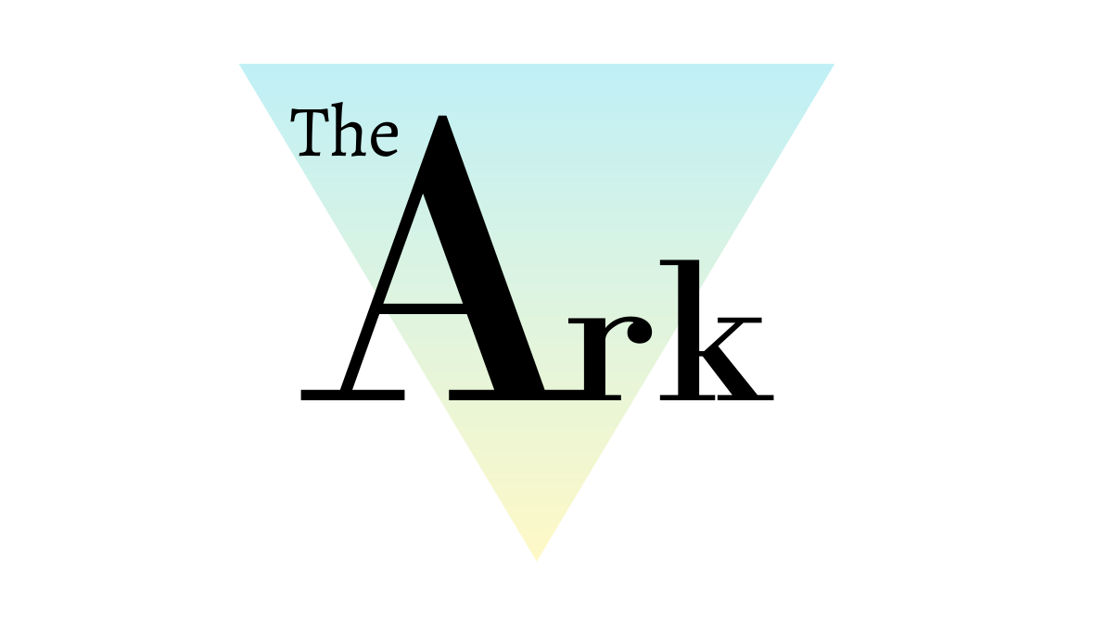

Anti-Bullying Policy

Policy Ref: ARK5v1

Produced by the Head of Centre, Head of Teaching and Learning

Prepared by: | Katie Davies | Reviewed by: | Steven Speed
Job Title: | Head of Teaching and Learning | Job Title: | Head of Centre
Signed: |  | Signed:
Date: |  | Date:

Record of Changes:

Version | Issue Date | Changes | Initials
V1 |  | Initial issue | SS

Date of Next Review:
July 2022

- Definitions
Throughout this policy document The Ark Wigan Ltd is referred to as ‘The Ark’.

- Introduction
The Ark is committed to ensuring that equality and diversity is promoted and championed throughout every aspect of our operations and that we fully comply with the requirements of all current, relevant legislation
The Ark has developed a Mission, Vision and Values Statement which embeds Equality and Diversity.
Through this, we are dedicated to the education and development of the whole person and supporting all students to realise their full potential. We will encourage our students to build the necessary skills and qualifications to support them through a unique and challenging environment where every individual is valued, talents are recognised and nurtured, achievements are celebrated, and dedication is rewarded.

To achieve this, we will:
- Welcome all students to provide equal opportunities and encouragement.
- Deliver high standards of teaching and learning for all abilities.
- Provide both relevant and accessible, industry standard equipment.
- Uphold an environment built on mutual respect, positivity, and inclusivity.
- Support and educate on the importance of mental health and well-being.
- Create, build, and develop local, national and international partnerships.

Core values in daily life at The Ark are expressed as:
- Independence
- Resilience
- Empathy
- Inclusivity
- Integrity
- Collaboration
- Innovation

- The Ark’s Aims and Objectives
The Ark, in accordance with our Mission, aim to provide a safe, caring, and friendly environment for all our students so that they may learn effectively, improve their life chances, and maximise their potential. We expect all students to feel safe in our education and training centre and to understand the issues relating to safety, such as bullying. We also want our students to feel confident to seek support from staff and their peers should they feel unsafe.

- Policy Statement
The Ark is completely opposed to all forms of bullying and will not tolerate it, under any circumstances.

All staff and students have the right to learn and work in a secure and caring environment, free from harm. They also have a responsibility to contribute, in whatever way they can, to prevent and report bullying behaviour. Preventative measures ensure that bullying is a rare occurrence at The Ark.

The Ark uses many measures to prevent bullying including:

- raising awareness,
- pastoral support,
- excellent classroom management and
- the promotion of positive interpersonal relationships.

Additionally, The Ark has strong community links with parents/carers, residents, Community Police Officers and local secondary schools and further education providers which supports its ethos and stance against bullying.

Our Anti Bullying Policy has been produced using information from other FE Colleges that we have liaised with, alongside statistics gathered from the surrounding area.

The Ark believes that:

• All students have the right to learn free from intimidation and fear
• The needs of the victim are paramount
• Bullying behaviour will not be tolerated
• Students who have been bullied will be listened to
• Reported incidents will be taken seriously and thoroughly investigated

- Key Documents and Duties
What is Bullying?

The Definition of Bullying is the ‘Behaviour by an individual or group usually repeated over time, that intentionally hurts another individual or group either physically or emotionally’. Safe to Learn: embedding anti bullying work in schools (2007).

Bullying differs from teasing/falling out between friends or other types of aggressive behaviour in that
• There is a deliberate intention to hurt or humiliate
• There is a power imbalance that makes it hard for the victim to defend themselves
• It is usually persistent

Occasionally an incident may be deemed to be bullying even if the behaviour has not been repeated or persistent – if it fulfils all other descriptions of bullying. This possibility will be considered, particularly in cases of sexual, sexist, racist or homophobic bullying and when young people/adults with disabilities are involved. If the victim might be in danger, then intervention is immediate.

Bullying can include:

• name calling
• taunting
• mocking
• making offensive comments
• physical assault
• taking or damaging belongings
• cyber bullying - inappropriate text messaging and e mailing; sending offensive or degrading images by phone or via the internet, inappropriate use of social media
• producing offensive graffiti
• gossiping and spreading hurtful and untruthful rumours about the student or his/her family • excluding people from groups

Although bullying can occur between individuals it can often take place in the presence (virtually or physically) of others who become the passive bystanders or ‘accessories’ and this can also constitute bullying.

Specific Types of Bullying can be related to:

• race, religion or culture
• special educational needs or disabilities
• appearance or health
• sexual orientation – homophobic or biphobic bullying, including use of homophobic or biphobic language
• gender identity – transphobic bullying, including use of transphobic language
• young carers or looked after children or otherwise related to home circumstances
• sexist or sexual bullying

There is no hierarchy of bullying. All forms are taken equally seriously at The Ark and dealt with appropriately.

Certain groups of students are known to be particularly vulnerable to bullying by others. These may include students with additional educational needs such as learning or physical disabilities; young carers, Looked After Children, those from ethnic and racial minority groups and those young people who may be perceived as lesbian, gay, bi-sexual, transgender or questioning their gender.

- Reporting and Responding

The Ark has clear systems for reporting bullying. The whole Ark community (including staff, parents/carers, children and young people) will be made aware of this via the website, tutorials programme, and the curriculum.

- Responsibilities
The Ark Staff will:

• Be alert to signs of distress and other possible indications of bullying
• Discuss bullying openly with all students, including the effects of bullying
• Listen and take time to talk to students/colleagues who disclose bullying, take what they say seriously and investigate the situation.
• Report suspected bullying through the appropriate pastoral/safeguarding channels
• Display anti-bullying messages throughout the college.
• Seek support from outside agencies if required
• Be a good role model
• Show all students and colleagues respect and treat all equally and fairly
• Be consistent with consequences for bullies
• Be sensitive when dealing with bullying issues
• Communicate effectively with all involved in working with the victim, include parents/carers even if there is little to report
• Boost self-esteem by praise, compliments and encouragement
• Safeguard all those who report bullying
• Use systems in place such as buddying, peer mentors, restorative approaches
• Ensure that unstructured times are supervised with staff strategically placed

The Ark Students will:

• Tell a trusted adult. Don’t suffer in silence
• Keep a diary (using the 4 Ws – who, what, where, when) to help staff deal with incidents
• Be a good friend to all who need one
• Walk away from dangerous situations or places
• Never join in with bullying behaviour
• Walk away from bullying and report it immediately
• Tell the truth about incidents / situations

The Ark’s Parents/Carers will:

• Inform The Ark of any suspected bullying, even if it is not their child
• Co-operate with The Ark and work together to prevent any long term damage from the effects of bullying
• Advise student not to retaliate with violence in any situation
• Encourage their child to report bullying to a member of staff using the 4 Ws – who, what, where, when
• Be non-judgemental and objective in their views, understanding there are two sides to every situation
• Allow The Ark time to investigate fully and be respectful of college decisions
• Be sympathetic and supportive towards their child and reassure them ensuring that their child understands that the bullying is not their fault
• If your child has been accused of bullying others, work in co-operation with the college and listen to the evidence
• Keep a written record of any reported incidence of bullying.

- Procedures
All reported incidents are taken seriously and investigated involving all parties as outlined below:
• Interviewing of all parties
• Written statements taken
• Informing parents/carers of ongoing incidents
• A range of responses appropriate to the situation utilised: - solution focused, restorative approach, circle of friends, individual work with victim, perpetrator, referral to outside agencies if appropriate
• Appropriate sanctions taken by college
• Follow up by the named person, keeping in touch with the person who reported the situation, parents/carers and staff
• Support for the victim and the bully
• Monitoring of the situation
• Named person for the victim to report any further incidents for continuous ongoing support • Reporting to Police, Careline etc as may be appropriate

Bullying outside of college

If an incident of bullying, involving The Ark students, outside of the education and training hours is reported, this will be investigated as above and appropriate action will be taken. This may involve advising parents/carers to inform the Police of incidents or supporting them and their child in seeking other outside agency support.

- Links with other Ark policies
Behaviour for Learning Policy
Safeguarding
E-safety Policy

