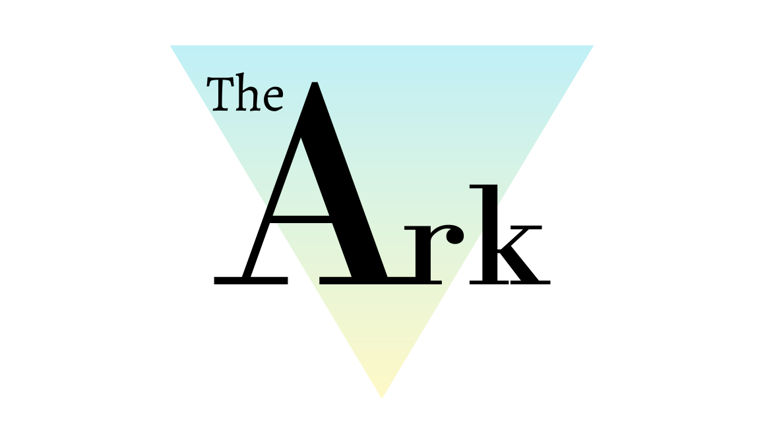

Compliments, Comments and Complaints Policy
Policy Ref: ARK7v1

Produced by the Head of Teaching and Learning. Reviewed by Head of Centre.
This policy will not discriminate either directly or indirectly against any individual on grounds of sex, race, ethnicity or national origin, gender, sexual orientation, marital status, religion or belief, age, disability, socioeconomic status, offending background or any other personal characteristic.

Prepared by: | Katie Davies | Reviewed by: | Steven Speed
Job Title: | Head of Teaching and Learning | Job Title: | Head of Centre
Signed: | 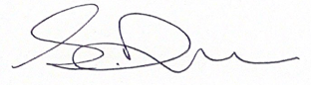 | Signed: | 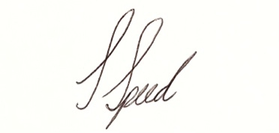
Date: | 09/02/21 | Date: | 09/02/21

Record of Changes
Version | Issue Date | Changes | Initials
v1 | February 20221 | Initial issue | SS
Date of Next Review: January 2022

- Definition
Throughout this policy document The Ark Wigan Ltd is referred to as ‘The Ark’.

- Introduction
This policy outlines how The Ark will deal with compliments, comments and complaints from customers and service users.
The Ark strives to achieve the highest standards of customer service for all. Service standards are monitored and maintained by department managers and senior leaders.
The Ark is committed to having a formal Compliments, Comments and Complaints Policy and Procedure which allows customers to provide valuable feedback about our products and services. This will ensure that we provide quality services for our customers and are responsive to their needs.
Customers are defined as: Students, External customers using The Ark facilities, Businesses, Organisations or individuals that The Ark works with or has a business relationship with.
The purpose of the Compliments, Comments and Complaints Policy is:
- To encourage customer feedback
- To provide effective means for people who use The Ark’s services to provide feedback, whether positive or negative
- To confirm the individual’s right to complain or share their opinions
- To ensure that compliments, comments and complaints are dealt with effectively and impartially
- To direct that complaints should be resolved:
- as quickly as possible
- as close to the point of delivery as possible
- fairly (for all parties)
- with the minimum of inconvenience to the Complainant
- In a consultative manner and with the aim of agreeing a solution
- To ensure that we respond to all suggestions, whether positive or negative, in a prompt, courteous and confidential manner as a key part of our customer service strategy
- To provide a framework for the delivery of the Compliments, Comments and Complaints Procedure
The Compliments, Comments and Complaints Policy will not be used to deal with staff disciplinary issues or grievance issues. There is a separate policy in place to cover these areas.
In some instances, a reported complaint might lead to an investigation under a separate policy. In this case the customer will be kept informed as appropriate.
The Ark does not entertain anonymous complaints in all but the most exceptional of circumstances.
The Ark takes the issue of malicious complaints very seriously. If, after investigation, a complaint is considered to have been made maliciously and/or without foundation then this could, if appropriate, result in disciplinary action against the person making the complaint.
All complaints and compliments are associated with The Ark and not with individual members of staff.
The objective of the complaints process is to investigate and improve the services that we offer and to be accountable to our customers and service users. The policy of The Ark is to respond to all suggestions, whether positive or negative, in a prompt, courteous and confidential manner. All complaints will be treated seriously.
All complaints will be dealt with fairly and decisions will be made on the balance of probabilities.
Any customer who feels that The Ark has not dealt effectively with their complaint may be referred to the relevant Prime provider. Customers will be informed of further details once the College process is exhausted.
The Compliments, Comments and Complaints Procedure below will detail minimum expectations, timelines, responsibilities and the agreed process for responding to Customer feedback.

- Objectives
The objective of this procedure is to:
- Implement the Compliments, Comments and Complaints policy for The Ark
- Ensure that The Ark responds to all suggestions, whether positive or negative, in a prompt, courteous and confidential manner in accordance with our customer service strategy
- Welcome feedback as an opportunity to improve the services that we offer
- Encourage a culture of openness around compliments / comments / complaints
- To direct that complaints should be resolved:
- as quickly as possible
- as close to the point of delivery as possible
- fairly (for all parties)
- with the minimum of inconvenience to the Complainant
- in a personal way, observing best practice for customer service
- To ensure that customer compliments, comments and complaints are used to develop overall improvements to the way that we work.

- Compliments and Comments Handling Procedure
All compliments and comments should be properly acknowledged, and the customer thanked for their feedback.
Compliments or comments received in writing should be acknowledged in writing
Whoever receives a compliment or comment should pass it on to The Ark’s Senior Management Team, so that they can understand customer feedback and drive recognition of good performance.

- Complaint Handling Procedure
Informal Complaints - Complaint handling formula
All compliments, comments and complaints will be treated seriously but should be dealt with informally in the first instance whenever possible and addressed at the point of delivery.
All team members are involved in customer service so may be involved in handling informal complaints. Team members dealing with a complaint should work to the following simple formula:
- Listen
- Ask questions
- Agree a solution – check satisfaction
- Implement the solution as soon as practically possible
- Follow up and check satisfaction
The aim should be to deal with less significant issues in an informal way at the point of service delivery to ensure a speedy resolution.
Internal Customers – Students
In the first instance, students should discuss their complaint with their Tutor. Many problems can be resolved with this direct interaction. If an immediate resolution is not possible, or the student is not satisfied with the outcome, they should inform their Tutor or another member of the staff team who will ensure that the matter is investigated informally. The member of staff will try to identify an informal solution to the problem.
If the student is not satisfied with the proposed informal solution, they may choose to then make a formal complaint to the Head of Centre.
If a student needs help in making a formal complaint, this can be obtained through Reception.
Students should approach The Ark with any complaint in the first instance.

External Customers
External customers are individuals, groups or organisations using The Ark’s facilities and businesses, organisations or individuals that The Ark works with or has a business relationship with.
Informal feedback should initially be directed to a member of staff within the area where the complaint is based. Complaints can often be resolved with this direct interaction
However, if the customer is not satisfied with the outcome, then they may choose to then make a formal complaint to the Head of Centre.
Formal Complaints
If the customer is not satisfied with the informal resolution to the complaint then the formal complaints process begins. Alternatively, a complaint can immediately be dealt with through the formal process if it is made direct to the Head of Centre and/or deemed serious enough to warrant the formal procedure.
The Head of Centre is responsible for logging and monitoring complaints but will not usually deal directly with complaints. The Ark’s policy is that complaints should be dealt with as close to the source of the complaint as possible – usually by head of the department about which the complaint has been made.
A formal complaint is one received in writing via letter or email or made over the telephone to the Head of Centre. Alternatively, a complaint initially dealt with informally can be made formal at the request of the customer or if it cannot be resolved informally. The Ark will not ask customers to put complaints in writing in order to trigger the formal complaints process
Formal complaints must be logged, investigated and the outcome recorded. The Head of Centre is responsible for monitoring complaints so must be made aware of formal complaints as soon as they are received.
Scanned/emailed copies of all complaints should be sent to the Director as soon as they are received
Notes of any telephone conversations should be taken and copies kept of all correspondence by the complaint owner.
Stage 1 – Receipt of complaint/processing/immediate response
Once the complaint has been received it is forwarded IMMEDIATELY (within 2 working hours) to the Assistant Head of Centre. Email should be used whenever possible.
This person then becomes the owner of the complaint
The complaint owner should contact the customer IMMEDIATELY (within 2 working hours or by 24 hours at the latest), by telephone, if possible, to explain that they are dealing with the complaint, to give the customer their contact details and to agree the timeframe for resolution.

Stage 2 – Investigation/Agreement of resolution/Confirmation of resolution
The complaint owner takes the following action:
- Investigate the complaint by interviewing staff or customers as necessary. Notes should be taken of phone calls and meetings
- Agree the resolution with the customer within two working days of receipt of the complaint or within the previously agreed timeline
- Resolution should be presented/agreed in person where possible or, failing that, by telephone. Resolution should only be presented in writing if no other contact details are available or if specifically requested by the complainant
- The target timeframe to agree a resolution to a complaint with all customers is within two working days of receipt. This may not be possible in complex cases, in which case the customer should be informed of the proposed timeframe to agree a resolution
- If the customer is satisfied then inform the Head of Centre of the agreed resolution and follow up in writing to the customer to confirm it within a further 5 working days
Stage 3 – Escalation
If the customer remains dissatisfied, then the complaint is escalated.
The Head of Centre is now the complaint owner and will do the following:
- Contact the customer IMMEDIATELY to explain that they are now dealing with the complaint and to agree the next step – in most cases this will be a face-to-face meeting
- Write to the customer to confirm that they are dealing with the complaint and to provide a copy of The Ark Compliments, Comment and Complaints Policy
- Meet with the customer or speak on the telephone and agree a solution/give a response
- Follow-up in writing
Stage 4 – Appeal
In exceptional circumstances, if the customer is still not satisfied after the previous steps they may appeal in writing. The appeal will be dealt with by an appropriate member of the Board within 14 days who will consult with colleagues who have been involved in the complaint, meet with the complainant to hear the appeal and give a final decision.
Stage 5 – Final Appeal
In very exceptional circumstances, if the customer is still not satisfied after the previous steps then the Chair of the Board will hear the final appeal and take advice from prime providers or other external sources where necessary.

