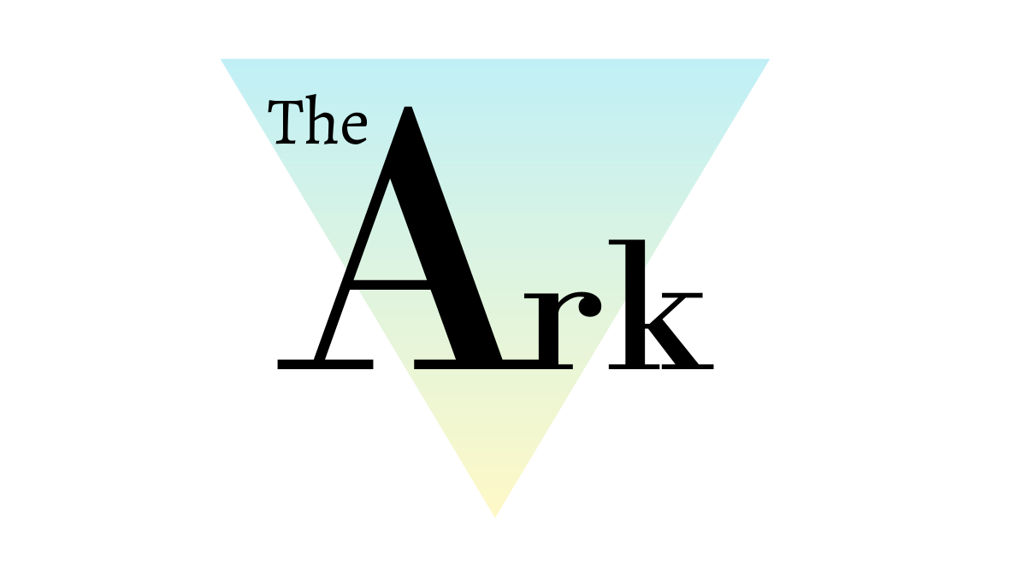

E-Safety Policy

Produced by the Head of Centre, Head of Teaching and Learning

This policy will not discriminate either directly or indirectly against any individual on grounds of sex, race, ethnicity or national origin, gender, sexual orientation, marital status, religion or belief, age, disability, socioeconomic status, offending background or any other personal characteristic

Prepared by: | Katie Davies | Reviewed by: | Steven Speed
Job Title: | Head of Teaching and Learning | Job Title: | Head of Centre
Signed: | 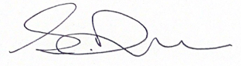 | Signed: | 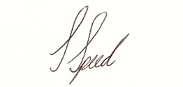
Date: |  | Date:

Record of Changes:

Version | Issue Date | Changes | Initials
V1 |  | Initial issue | SS

Date of Next Review:

- Definition

Throughout this policy document The Ark Wigan Ltd is referred to as ‘The Ark’.

- Policy Statement

This e-Safety Policy relates to all curriculum subjects taught within The Ark including those for Personal, Health, Spiritual, Moral, Social and Cultural Education (PHSMSC).

The policy provides a method to review The Ark’s practice in the use of technology and its benefits and risks.

This e-Safety Policy and its implementation will be reviewed annually or as required in the light of any issue, risk assessment or development that requires a review to support the safety of staff or students at The Ark.

- The Ark’s Aims and Objectives

The Ark, in accordance with our Mission, aim to provide a safe environment for our students, which also means safety online. We understand the benefits that the internet can bring to improve their education and learning but we expect all students to feel safe when using it.

- Policy Statement
As per the DfE guidance, Keeping Children Safe in Education (Sep 2019), The Ark staff are required “protect children from maltreatment; preventing impairment of children’s health or development; ensuring that children grow up in circumstances consistent with the provision of safe and effective care; and taking action to enable all children to have the best outcomes.”

Further information on social media platforms and safety can be found on
http://www.saferinternet.org.uk/advice-and-resources/teachers-and-professionals/safety-features

When using new technologies, Ofsted guidance also states that it is essential for The Ark to have a comprehensive e-Safety policy in place and the right tools to provide the safest educational environment possible. As data protection and e-Safety are increasingly important concerns for all learning communities, we will ensure update training in these areas of responsibility.

The most recent threat being identified through access to the internet, in particular social media, is being used as a channel, not only to promote and engage, but also as Robert Hannigan (Director of Government Communications Headquarters) recently suggested, as a command structure. Often this promotion glorifies violence, attracting and influencing many people including children and in the extreme cases, radicalising them.

The Ark students are particularly vulnerable to this influence as they are trusting and not necessarily able to appreciate bias that can lead them to be drawn into these groups, adopt extremist views, and become normalised to shocking and extreme content. This threat is not just from groups, such as Islamic State, but from ‘far right’ groups also. This can be familiarised to the grooming processes when others with influence are manipulating vulnerable young people in order to abuse them in the future. The risk of extremism and radicalisation is a similar process which ultimate exploits the same vulnerabilities

- Key Documents and Duties
Other key documents are noted, which have prompted changes to e-safety requirements over time. This policy references these throughout where relevant:

DFE, Keeping Children Safe in Education (Sep 2019); https://www.gov.uk/government/publications/keeping-children-safe-in-education--2

http://www.saferinternet.org.uk/advice-and-resources/teachers-and-professionals/safety-features

https://ico.org.uk/for-organisations/data-protection-act-2018/

https://ico.org.uk/for-organisations/guide-to-data-protection/guide-to-the-general-data-protection-regulation-gdpr/

- Teaching and Learning

Importance of internet use:

- The purpose of internet use in The Ark is to raise educational standards, to promote student achievement, to support the professional work of staff and to enhance the management functions
- Internet use is part of the statutory curriculum and a necessary tool for learning
- Internet access is an entitlement for students who show a responsible and mature approach to its use
- The internet is an essential element in today’s life for education, business and social interaction. The Ark endeavours to provide students with quality internet access as part of their learning experience.
- Students use the internet widely outside The Ark and will need to learn how to evaluate internet information and to take care of their own safety and security.
Benefits

- Access to world-wide educational resources
- Access to national networks
- Access to educational and cultural exchanges between students world-wide
- Vocational, social and leisure use in libraries, clubs and at home
- Access to support services and professional associations for staff and students.
- Access for staff to professional development, educational materials and good practice
- Exchange of data
- Access to learning wherever and whenever convenient
Enhancing Learning through internet use

- The Ark’s ICT external network provider will support the filtering of the internet access to match the appropriateness of sites for students use
- Students will be taught what internet use is acceptable and what is not and given clear objectives for internet use
- Internet access will be planned to enrich and extend learning activities
Evaluating internet content:

- The copying and use of internet derived materials by staff and students must comply with copyright law
- The evaluation of on-line materials is a part of every subject and critical awareness and validation of information is fundamental to accepting its accuracy for staff and students alike
- Any information used must be acknowledged and respected according to copyright by staff and students.

- Managing Information Systems:

- The Ark’s ICT external network provider will advise on any necessary adjustments in order to manage information systems safely and efficiently
- The security of the The Ark information systems will be reviewed regularly
Managing e-mail

- Students may only use approved e-mail accounts
- Offensive e-mails must be reported immediately
- Student personal details must not be revealed in e-mails, nor any arrangements made to meet others without specific permission
- The forwarding of chain letters is not permitted
Managing Published Content

- The contact details on the website should be The Ark address, e-mail and telephone number. Staff or student’s personal information must not be published
- Images that include students will be selected carefully and will comply with the digital image procedure, as detailed below
- Students’ full names, ages, addresses will not be used anywhere on the website, particularly in association with photographs
- Written permission from parents or carers will be obtained before images of student are electronically published and held at reception
- Work can only be published with the permission of the student and parents
- Images of staff will require permission from the staff member before being published on The Ark’s website
Managing social networking and personal publishing

- There will be filtered access to social networking sites and blocking where needed
- Newsgroups will be blocked unless a specific use is approved
- Students will be taught, advised and reminded never to give out personal details of any kind which may identify them and/or their location, including not to place personal photos (with or without background detail identifying them or their location) on a social network space
- Student cover e-Safety in the first half term of every academic year
- Strategies to avoid cyber-bullying should be in place to protect staff and students.
Managing filtering

- The Ark will work with external ICT network provider and internet service provider to ensure that systems to protect staff and student are reviewed and improved
- Unsuitable sites must be reported to Senior Management immediately

- Emerging Technologies

Emerging technologies or introduction of technologies not previously used in The Ark must be thoroughly risk assessed. e.g. web cams, video conferencing, blue tooth, wireless, infra-red, text messaging

- Personal Data

Personal data will be recorded, processed, transferred, and made available according to the Data Protection Act 2018 and General Data Protection Regulation (GDPR).

- Authorising Internet Access

Internet access will be by signed agreement consent form from student or parents. Any non-compliance with e-Safety rules will be dealt with through the disciplinary procedures.

- Risk Assessment

- The Ark will take reasonable precautions to prevent access to inappropriate materials or inappropriate internet use but it cannot guarantee The Ark’s computer or ICT equipment is not misused.
- Regular review of risk assessment methods will endeavour to minimise risks.
- Complaints of internet misuse will be dealt with by a senior member of staff.
- Staff misuse complaints must be referred to the Director.
- Student and parents will be informed of the complaint’s procedure.
- Safeguarding issues must be referred to the Director.

- Communications Policy

a) To Students
- In lessons to teach e-safety
- Posters and displays
b) To Staff
- Awareness raising and training
- Consultation and involvement in policy and practice reviews including reporting issues procedure
c) To Parents
- Partnership approach at Parents’ Evenings, through newsletters, admission. The Ark’s course information and website, leaflets and flyers to draw attention to The Ark’s e-Safety Policy.
- Advise parents sensitively of issues

- Related Policies and Procedures
This policy should be read alongside the following policies relevant to the safety and welfare of our students. Related Policies and Procedures

- Safeguarding and Child Protection Policy
- Equality and Diversity Policy
- Anti-Bullying Policy
- Data Rights Policy
- Data Protection GDPR Policy

