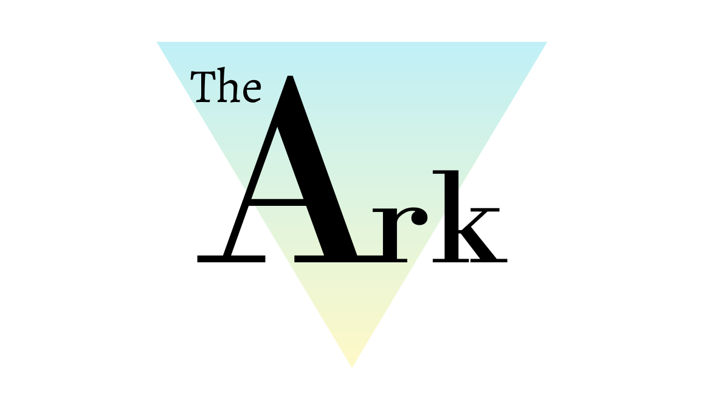

Accident & Incident Recording and Reporting Policy

Policy Ref: ARK10v1

Produced by the Head of Centre, Head of Teaching and Learning.

This policy will not discriminate either directly or indirectly against any individual on grounds of sex, race, ethnicity or national origin, gender, sexual orientation, marital status, religion or belief, age, disability, socioeconomic status, offending background or any other personal characteristic.

Prepared by: | Katie Davies | Reviewed by: | Steven Speed
Job Title: | Head of Teaching and Learning | Job Title: | Head of Centre
Signed: | 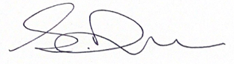 | Signed: | 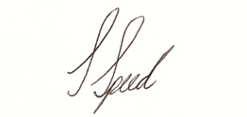
Date: | 01/09/21 | Date: | 01/09/21

Record of Changes:

Version | Issue Date | Changes | Initials
V1 |  | Initial issue | SS

Date of Next Review:
July 2022

- Definitions
Throughout this policy document The Ark Wigan Ltd is referred to as ‘The Ark’.

What is the difference between an accident and an incident?
- An accident is an unfortunate event or occurrence that happens unexpectedly and unintentionally, typically resulting in an injury, for example tripping over and hurting your knee.
- An incident is an event or occurrence that is related to another person, typically resulting in an injury, for example being pushed over and hurting your knee.

- Introduction
The Accident and Incident Reporting Policy is to support students, potential students, staff (in relation to supporting students), employers, stakeholders, and the public to ensure The Ark is a safe place.

- The Ark’s Aims and Objectives
The Ark, in accordance

- Policy Statement
The Ark follows the guidelines of the Reporting of Injuries, Diseases and Dangerous Occurrences Regulations (RIDDOR) and the Health & Safety Executive (HSE) for the reporting of accidents and incidents.

Child protection matters or behavioural incidents between children are not regarded as incidents for this purpose. Please see section 9 for related policies.

- Key Documents and Duties
Dealing with Accidents to Staff, Volunteers or Other Adults
We keep written records of all accidents or injuries to staff, volunteers or other adults together with any first aid treatment given.

The accident is recorded in the “Accident and Incident Book” by the adult who has had the accident or if this is not possible, by the First Aider on site.

The Accident and Incident Book is kept in a safe and secure place. It is regularly reviewed to identify any potential or actual hazards or any other issues that need to be addressed.

Dealing with Incidents and Dangerous Occurrences
We meet our legal requirements for the health and safety of all adults and children by following the RIDDOR guidelines and reporting any incidents and dangerous occurrences to the HSE (and any other appropriate professional bodies).

An incident may be an event that causes injury or fatalities or an event that does not cause injury but could have done so, such as a gas leak. Any dangerous occurrence is recorded in our “Accident and Incident Book”.

On discovery of an incident, we report it to the appropriate emergency services – fire, police, and ambulance – if those services are needed. We also have contact numbers for suitable services such as gas and electric emergency services.

If an incident occurs before any learners arrive, we risk assess this situation and decide if the premises are safe to receive learners. We may decide to offer a limited service or to temporarily close the Education and Training Centre.

Where an incident occurs whilst the learners are in our care, and it is necessary to evacuate the premises we follow the procedures in our Emergency Evacuation Procedure.

If a crime may have been committed, we ask all adults who witness the incident to make a witness statement including the date and time of the incident, what they saw or heard, what they did about it and their full name and signature

- Reporting of Accidents or Illnesses

Ofsted is notified as soon as possible, but at least within 14 days of any instances which involve:

- food poisoning affecting two or more adults/children looked after on our premises.
- a serious accident or injury to, or serious illness of, a child/adult in our care and the action we take in response; and
- the death of a child/adult in our care.
Local child protection agencies are informed of any serious accident, illness, or injury to, or the death of any child or vulnerable adult while in our care and we act on any advice given by those agencies.

The local Environmental Health Department is informed of any food poisoning affecting two or more children or adults on our premises.

We meet our legal requirements in respect of the safety of our employee and the public by complying with RIDDOR. We report to the Health and Safety Executive (HSE):

- Any work-related accident leading to an injury to a member of the public (child or adult), for which they are taken directly to hospital for treatment.
- Any work-related accident leading to a specified injury to one of our employees.
- Specified injuries include injuries such as fractured bones, the loss of consciousness due to a head injury, serious burns or amputations.
- Any work-related accident leading to an injury to one of our employees which results in them being unable to work for seven consecutive days. All work-related injuries that lead to one of our employees being incapacitated for three or more days are recorded in our “Accident and Incident Book”.
- When one of our employees suffers from a reportable occupational disease or illness as specified by the HSE.
- Any death, of a child or adult, that occurs in connection with a work-related accident.

- Responsibilities
The Ark Staff will have a responsibility for logging and recording any incidents or accidents they have or witness in the logbook. Staff are expected to help support a log where necessary, including if the log needs help completing the log in the logbook.

All managers have a responsibility for reviewing the logbook and notifying the Head of Centre to any incidents that seem repetitive or hazardous. The Head of Centre is responsible for resolving these incidents and accidents in the best way possible.

- Procedures
We keep an “Accident and Incident Book” for recording all of the incidents and dangerous occurrences detailed below, including those that are reportable to the HSE as above. In the Accident and Incident Book, the date and time of the incident is recorded together with the nature of the event, who was affected and how it was dealt with. If the incident is reported to the police, we make a note of the crime reference number. Any follow up or insurance claim made is also recorded.

The Accident and Incident Book is not for recording issues of concern involving a learner. The procedure for dealing with issues of concern is given in separate Safeguarding policies.

Break in, burglary, theft of personal or setting property

In the event of finding there has been a break in, burglary or theft, the Head of Centre should be informed immediately either in person (or by phone if he is not working). If the Head of Centre cannot be contacted, the Safeguarding Lead should be informed.

Anything that may be deemed to be evidence or unsafe should not be touched. The Head of Centre will inform the police and make decisions on the advice of the police about the opening or closure of the setting and will follow any procedures set out by the police

Intruder gaining unauthorised access to the premises or grounds

If someone is acting suspiciously on the Education and Training grounds or premises, this must be immediately reported to the Head of Centre or Safeguarding Lead.

All children and vulnerable adults should be brought inside the Education and Training building straightaway, and all doors shut and secured as appropriate. If the person appears to be a threat to the staff or learners, all doors should be locked with keys, windows shut and the blinds pulled down. Learners must be kept calm and where possible, must not be made aware of the situation. Staff must act calmly and discreetly.

The safety of the learners, staff and other adults is paramount. Observations must be reported to the Head of Centre before an intruder is confronted. If anyone’s safety is under threat, the Head of Centre will contact the police and take advice from them before any learners or staff are released from the building.

After the incident, the Head of Centre will take advice from the police before releasing any information to the parents.

Fire, gas leak or electrical failure

In the event of discovering a fire, the fire evacuation procedure should be followed.
If a gas leak is suspected, this must be immediately reported to the Head of Centre or Safeguarding Lead who will call the national emergency number 0800 111 999.
All learners, staff and other adults should immediately leave the building and remain in the outdoor area until the building is declared safe by the gas distributor. All doors and windows should be opened. Electrical switches should not be turned on or off – including light switches and doorbells.

Make sure that the gas supply to an appliance has not been left on or that the pilot light on the boiler has not gone out. Turn off the gas supply at the meter if you know how to.
If an electrical failure occurs, this must be immediately reported to the Head of Centre or Safeguarding Lead. They will contact the electricity distributor to inform them of the failure and find out when the supply can be restored. The Head of Centre will decide whether Education and Training can remain open without an electricity supply.

Attack on an adult or child on our premises or nearby

This must be immediately reported to Head of Centre or Safeguarding Lead. They will call the police, ensure any first aid is provided and contact the emergency medical services.
The safety of the learners, staff and other adults must be secured. Learners should be appropriately looked after, moved to a safe part of the building, and kept calm.

Adults should remember that it is best not to antagonise the situation or retaliate in any way. It is important to try and diffuse the situation and retreat to safety.

Any racist incident involving staff or family on the premises

A racist incident is any incident which is perceived to be racist by the victim or any other person. If such an incident occurs, this must be immediately reported to Head of Centre or Safeguarding Lead. They will call the police and follow their advice as appropriate.

Death of a child or adult on the premises

In the event of a death at The Ark, the Head of Centre or Safeguarding Lead will ensure that the following steps are taken:

- The police are immediately informed.
- The parent or guardian is informed.
- The other learners at the pre-school are appropriately looked after and kept calm.
- Parents will be called to collect children as soon as possible.
- Additional staff will be called in to help look after the learners if necessary.

A terrorist attack or the threat of one

If information is received about the threat of a terrorist attack in the vicinity of Education and Training Centre, this must be immediately reported to the Head of Centre or Safeguarding Lead. They will then call the police and advise the procedures to follow based on advice given to them from the police.

The safety of the learners, staff and other adults is paramount. If anyone’s safety is under threat, the Head of Centre will contact the police and take advice from them before any learners or staff are released from the building. Learners must be kept calm and where possible, must not be made aware of the situation. Staff must act calmly and discreetly.

After the incident, the Head of Centre will take advice from the police before releasing any information to the parents.

A notifiable disease or illness, or an outbreak of food poisoning affecting two or more adults/children looked after on our premises

These occurrences are to be recorded in the Accident and Incident Book.
Outbreaks relating to the Covid19 Coronavirus may need to be reported to the local public health body. Full details of the actions to be taken in relation to Covid19 outbreaks are given in the policy “Coronavirus (Covid-19) Safety Policy”

- Links with other Ark policies

- Safeguarding Policy - Child Protection Policy
- Safeguarding Policy - Adults at Risk
- Bullying and Harassment Policy
- Learner Disciplinary Policy

